What is validation:  
› Validation: Checking that the specification matches the user’s requirements  
  
**I Reviews and inspections**   
Analyse artefacts such as requirements documents, design diagrams and program source code Reviews Why make informal reviews?   
I Everyone makes mistakes   
I Create open atmosphere (increase productivity)   
I Find errors in program early (before it is run the first time)   
I Find quality issues   
I Improve programming skills of all involved   
I Anything can be reviewed (. . . , use cases, documentation, . . . )  
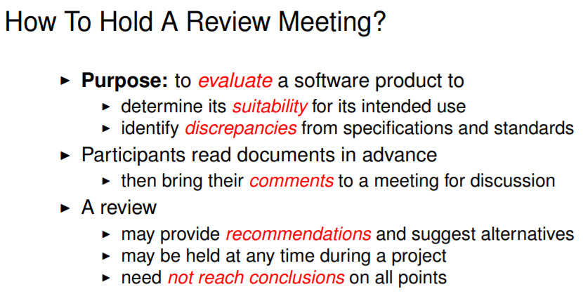

Tell something about inspection  
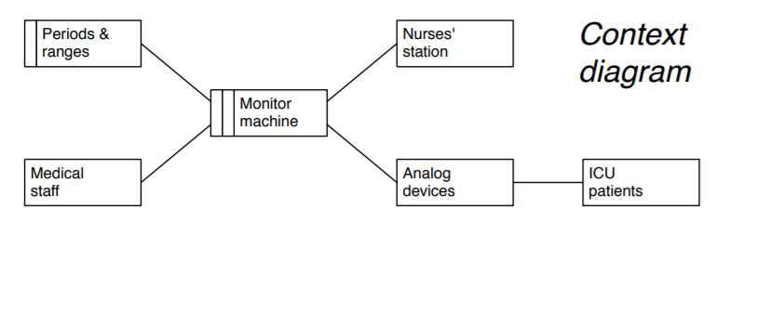  
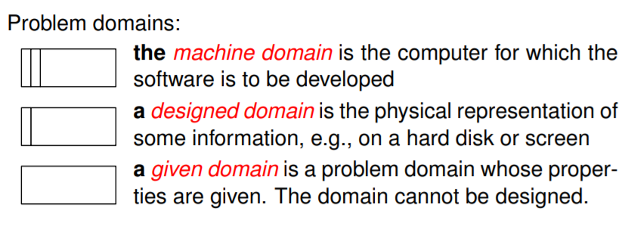

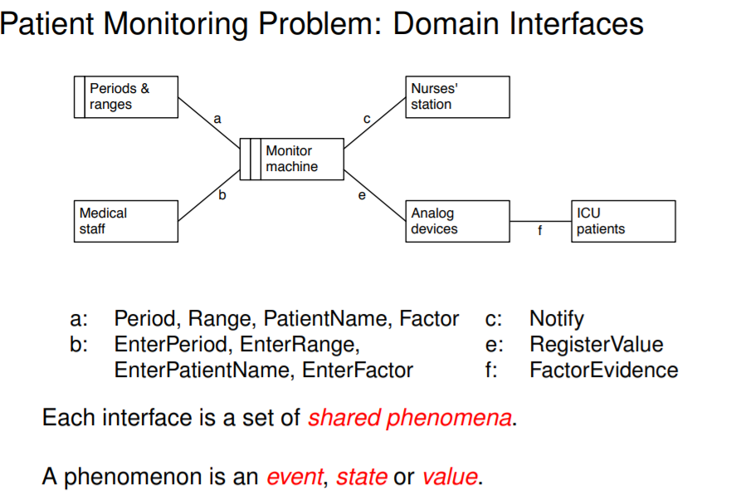

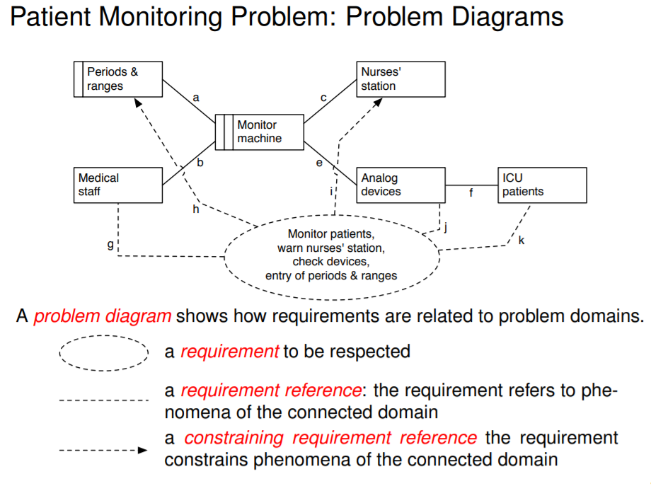

UML:  
Class diagrams  
Sequence diagram  
State diagram  
Use cases